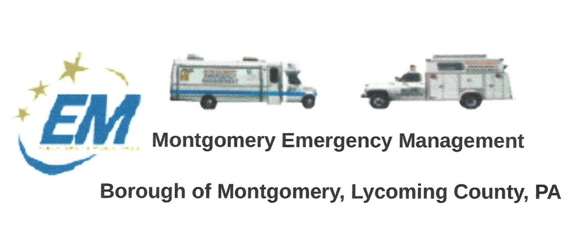

**Greg Gruver, EMA Coordinator. 77 East Houston Avenue, Montgomery, PA 17752**

Telephone: 570-547-1212 Cell: 570-419-4866 Email: [montema631@gmail.com](mailto:montema631@gmail.com)

**Fae Herb, Administrative Assistant. 102 Broad Street, Montgomery, PA 17752**

Cell: 570-506-9892 Email: [faeherb@aol.com](mailto:faeherb@aol.com)

Meeting Room and Equipment Building: 40 Thomas Avenue

Borough EOC: 570-547-1671 Fire Hall EOC: 570-547-1380

**INTERNET WEBSITE: www.montgomeryboroughema.org**

**January Newsletter**

The **regular monthly meeting** of the Montgomery Emergency Agency will be:

THURSDAY, FEBRUARY 10TH, 2022

We welcomed the year 2022 with mild temperatures. Sixteen days later our “magical” snowfall made

the WNEP-TV News weather segment. As the snowfall rose to 5 inches on the gauge, it depleted down

to just 1 inch due to the rain our area received. Our thanks to our members who plowed the wet heavy

snow in the parking lot and sidewalks.

Unfortunately COVID is still with us in our County, and we thank Les for updating on our EMA Facebook

Page with the information of how many cases within our State, County and 17752 zip code area.

He also keeps the locals updated on upcoming weather conditions, which is very helpful to those of

Us who need to travel to work.

The EMA meeting room has been seeing improvements, Greg and Dennis painted the ceiling. More

Improvements will be in place when warmer temperatures arrive.

We are always seeking new members to join and encourage all of us to reach out to people

To consider becoming a member of the Emergency Management.

Stay informed on the Montgomery Emergency Management Facebook Page as well as the website.

Next meeting will be Thursday, February 10th at 7 p.m.